|  |
| --- |
| Mobile Mini-Powersupply |
| Created With “Advanced Ultimate Box-Maker using OpenSCAD |
|  |

01.09.2021 Version 1

Miguel Ostermann

Electronic

Table of contents

Introduction 0

Main design aspects of the DIY Powersupply 0

The “Advanced Ultimate Box-Maker” with OpenSCAD 0

Features of the Powersupply 0

Explanations of the parts 1

Buck-Boost converter DPH-5005 1

Li-ion charger Typexx 1

Protection module for batteries 1

# Introduction

For my projects in electronics I often need an appropriate housing.

Commercial products have the disadvantage that they don’t fit exactly and cause a lot of work for manual drilling, cutting, adapting, etc.

I needed a software solution for creating an individual box using a 3D-printer.

* The software must have mainly a parametric design so that the properties of the box can be easily changed.
* The software must have a GUI for changing the parameters so that the program code does not need to be changed.
* Ideally the software allows to save the parameters in individual files.

The software with the less disadvantages I could find, was OpenSCAD.

It is relatively easy to learn and has a so called customizer for changing and saving the parameters. But it has also a lot of restrictions to deal with. Despite this OpenSCAD was the first choice. My normally used CAD-Software “Fusion-360” is nice to use but has only a bit of a customizer.

For that reason, the decision was using OpenSCAD and I searched around which programs exists to solve my problem.

I found the “Ultimate Box Maker” with its forks and put me on to extend the features of these programs with help of some excellent libraries.

The result is this “Advanced Ultimate Box Maker”. (see the appropriate Docu)

## Main design aspects of the DIY Powersupply

* The powersupply should be cheap and easy to build.
* It should consist of ready to use modules.
* Powersupply should be powered by chargeable batteries or external AC-adpater.

# The “Advanced Ultimate Box-Maker” with OpenSCAD

For Description of the features, the installation and how to use the software please read the paper “Advanced ultimate-Boxmaker”

### Features of the Powersupply

* Outputvoltage 0-50V up to 5A
* Constant current, Constant Voltage (CC, CV)
* Switchable operation between AC and battery
* Battery-Indicator
* Autom. battery charge during AC-operation
* Remote control over Bluetooth with smartphone app or USB PC-App

# Explanation of the parts

## Buck-Boost converter DPH-5005 from Ruideng

It is a ready-to-use kit from china. It has 4 modules:

* The converter itself
* the control-panel with the display
* Add. Consists of an USB-interface and
* Bluetooth-Interface for remote control of the powersupply.

## Li-ion charger module

Charging module (3S) for charging the three 18650 cells during AC-mode.

Charges the cells with 0.5A and has a charge cuttoff voltage of 12.6V.

## Protection module for batteries (BMS)

This module protects the batteries in several manner:

* Overvoltage during charging
* Undervoltage during discharging
* Overcurrent protection for discharging

## AC-adapter with 19V / 4.5A

The AC-adapter is switchable between 12V – 24V. 19V is the recommended voltage output.

## 3x Li-Ion battery cell 18650

Samsung INR18650-25R 2500mAh cells without protection

# Module view of the Powersupply

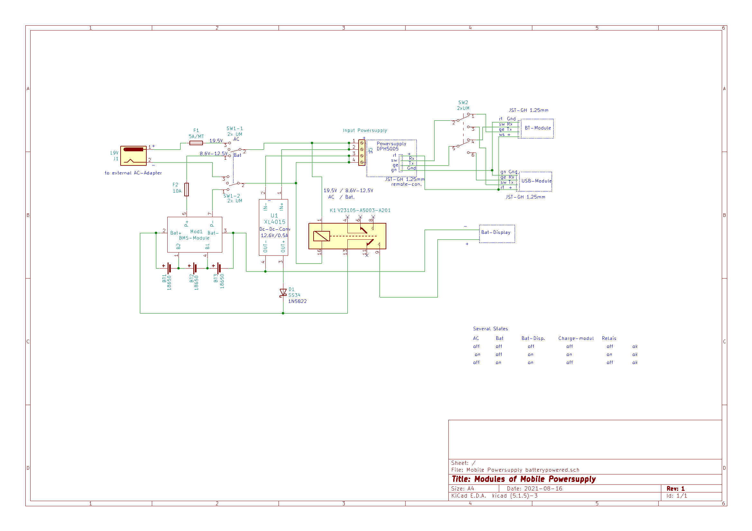

# Bill of Materials (BOM)

The parts are rather cheap and the source of supply is mostly in china and ebay

|  |  |  |
| --- | --- | --- |
| Description |  | price |
| DPH5005 Buck-boost converter with USB- and BT-communication | https://de.aliexpress.com/item/32840324731.html | 47€ |
| XL4015 5A DC-DC Step Down converter | <https://www.ebay.de/itm/402597361624> or  <https://www.aliexpress.com/item/32891328430.html> | 3,70€  2,30€ |
| 270g/93m Filament 1.75mm PLA grey |  | ~5,00€ |
| Axicom D2N12-960Relay DPDT (2xUM)  V231005-A5003-A201 | Kessler electronic  <https://www.ebay.de/itm/111447113032> | 2,30€ |
| BatteryIndicator LEDdisplay | Naltronic  <https://www.ebay.de/itm/123571387480?var=424142377263> or  <https://www.aliexpress.com/item/1005002375550407.html> | 5,80€  2,80€ |
| Battery-BMS, BalanceBoard, 6A-8A max  Mesacomponents | <https://www.ebay.de/itm/254159873534?var=553510124474> or  <https://www.aliexpress.com/item/4000385806747.html> | 9,90€  2,30€ |
| Switch On-off-on  Wippschalter Ein-Aus-Ein | <https://www.aliexpress.com/item/32967528231.html> or  <https://www.ebay.de/itm/264813617899> | 2,20€  6,00€ |
| Submini slide switch DPDT  Submini-Schiebeschalter 2xUM | Kessler electronic  <https://www.ebay.de/itm/311859237255> | 1,00€ |
| Powerplug High-Amp Switchcraft SC1943-ND | Digikey  <https://www.digikey.com/en/products/detail/switchcraft-inc/S1017/3909312> | 7,00€ |
| Threated inserts M3x6g  Gewindeeinsätze M3x6g (gegenläufig) | Msr-coptertools  <https://www.ebay.de/itm/173779404364> | 6,00€ |
| Fuse-Holder  Sicherungshalter Snapin SH8 | Centralsystems-isp  <https://www.ebay.de/itm/284368894849> | 3,55€ |
| Fuse-Holder incl Si. 5A , 5x20mm, 12mm° | <https://www.ebay.de/itm/173575874739> | 3,50€ |
| Schottky-Diode 1N5822 | <https://www.ebay.de/itm/254069873397> | 3,00€ |
| Kfz-Flachsicherungen 10A | <https://www.ebay.de/itm/233933295008> | 2,50€ |
| Laptop AC-Adapter 12V-20V / 4.5A (19V-20V) | flystorefly  <https://www.ebay.de/itm/402696857628> | 18,20€ |
|  | Amount, Summe | 109€ -125€ |

Hh